

ASSOCIATION FOR LANGUAGE LEARNING: LONDON REGION BRANCH
www.all-london.org.uk

The ALL London June Event 2026
Celebrating ‘London Festival of Languages 2026’

on Saturday June 13th 2026 09:30 –13:45
at The Grey Coat Hospital C of E Comprehensive School for Girls
St. Andrew’s building, Greycoat Place, London, SW1P 2DY
[not St Michael’s Regency Street]
NB: Ring the bell and we open the door! (see page 2 for maps)
- Tube: Victoria, St James’s Park – approx. 6 minute walk; Buses: Bus services 3, 11, 24, 26, 36, 44, 148, 170, 185, 211, C10, 2, 6, 13,stop near the school. Please check ahead for any planned engineering works which may affect travel; https://tfl.gov.uk/status-updates/planned-track-closures
Once registered, please watch your mailbox for messages from us.
Registration: http://tinyurl.com/alljuneevent26 [or scan QR code above]
PROVISIONAL PROGRAMME AS 26/04/26 [Subject to slight changes]
9.30 | GREAT HALL: Registration & Exhibition. Tea/coffee and biscuits – the committee and exhibitors will be here to welcome you!
10.00- 10.20 | GREAT HALL: Welcome from Helen Myers, Chair of ALL London. Updates from ALL London including the London: City of Languages Festival!
10.20 – 11.30 | GREAT HALL: Celebrations, Competitions and Quizzes – Nathalie Blondeau et al  For all sectors – a collective ‘show and tell’ showcasing multilingualism and creativity.  Activities will support preparations for:  - European Day of Languages (26 September)  Europe has over 200 languages; the day highlights how multilingualism strengthens cultural understanding, mobility and cooperation.  - International Mother Tongue Day (21 February)  Promotes linguistic and cultural diversity, supports multilingualism, and raises awareness of the importance of preserving mother tongues worldwide.
11.30 – 12.00 | GREAT HALL: EXHIBITION Comfort break / top-up of coffee / chance to ‘network’ / view info sent from corporate members, ALL & Language Institutes. Raffle prizes to be won!
12.00 – 12.45 | GREAT HALL: Planning a promotional campaign for languages (2026–27), covering GCSE and A level. Catherine Ames (The Grey Coat School) and Kate Melhorn (St. Dunstan’s College) will share their experiences, incl. an amazing ‘Careers’ Fair’ which has had an incredible impact on uptake. To include a briefing from David Blow on Progress 8 consultation and its implications for ML. OR  CLASSROOM: Primary colleagues will be led by our superb hub coordinators to share good practice. Please bring your ideas and enthusiasm to listen and/or contribute. OR  CLASSROOM: Communities of Practice Fatima Khaled will consider how we can work more collaboratively with different stakeholders to support heritage learners.
12.45 – 1.10  1.15 – 1.40 - | CLASSROOMS : Carousel of ‘Language Taster’ Experiences Focusing on less-taught / HHCL languages – open to all sectors. To include: Arabic, Czech, Portuguese, Punjabi, Japanese. Bring your own picnic to keep you going. We will provide the squash!
&  later | GARDEN – have a quick snack / drink in the garden to socialise before you continue your day!  From such a central venue, you are spoilt for choice: Westminster Abbey (have you seen the Queen’s Diamond Jubilee Galleries?) - National Gallery – Banqueting House (newly renovated)
EARLY BIRD BEFORE MIDNIGHT TUESDAY 9TH JUNE ‘26: (Thereafter, £10 extra)
£1 [Pay £11 and get a £10 refund if you attend]– Students, and 'first-timer' Primary teachers and Community languages teachers [We will refund your registration fee if you attend - you only pay the admin fee]
£10 ALL individual members (incl. retired) or people who join on the day. £20 – group members,
£35 – non-members.

Follow this link to join ALL: http://www.all-languages.org.uk/join/join_us

Please note that we deliberately keep down the cost of courses by subsidising them from ALL funds: we feel that members ought to receive value for the money paid in subscription fees to the Association. Fees charged do not, in any way, reflect the quality of courses offered!

If your organisation needs to make a direct transfer to BACS, please contact us [info@all-london.org.uk] for details. Thank you.

Our Exhibitors

We are very grateful to our Corporate Members who provide a useful and informative exhibition at our events, and welcome the chance to speak with us. Thank you to Angela Murphy who organises this. Please contact us via info@all-london.org.uk if you are a corporate member of ALL and would like a stand.

Maps and photos
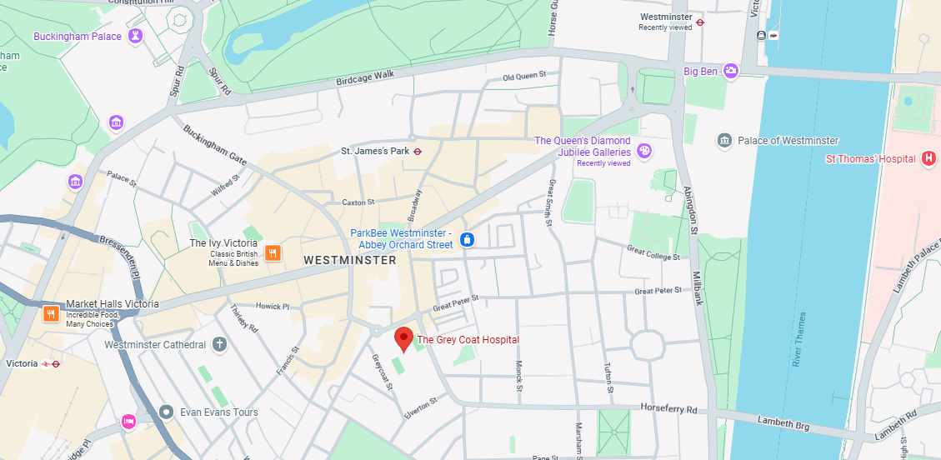
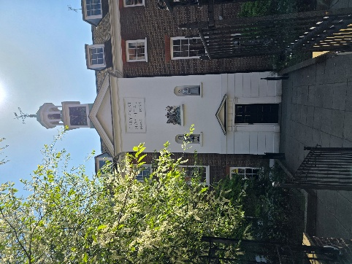
The Grey Coat Hospital C of E Comprehensive School for Girls
St. Andrew’s Building, Greycoat Place, London, SW1P 2DY

Victoria / St James’s Park: 6 mins walk
Westminster: 15 mins walk

Entrance

