As published 31-Dec-23

Guide to severe grading in ML exams
for teachers and senior leaders

What is severe grading?
It should be that pupils of the same prior attainment gain, on average, a similar GCSE grade in their EBacc subjects (English, maths, sciences, history / geography and a language). But there has been a discrepancy going right back to the days of O-level whereby languages (blue lines in graph to right) have had a lower average grading – by over half a grade for many students. (The same principle should hold at A-level, with prior attainment measured by GCSE score).

Evidence
FFT Datalab have analysed the grades over a number of years, giving clear quantitative evidence, most recently in June 2023:
https://ffteducationdatalab.org.uk/2023/06/revisiting-subject-difficulty-at-key-stage-4/
- Comparison with English and Maths - they compared
(i) the grade achieved by each pupil in subjects to
(ii) their average score in English and maths.
The graph is striking, showing that on average their grades in German, French and Spanish were 0.7, 0.7 and 0.6 grades lower than their average grade in English and Maths, whereas all the other EBacc subjects were within 0.2 grades of their average grade in English and Maths.
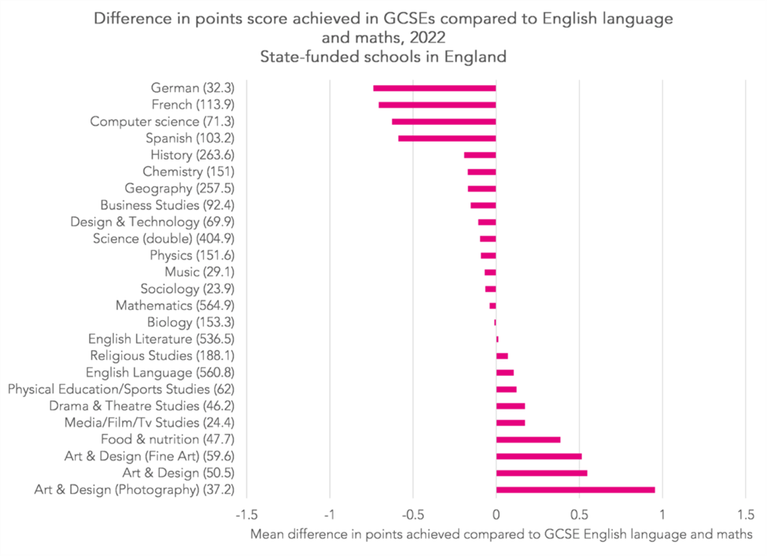

Students, teachers and parents will often compare their grades in different subjects, and assume, incorrectly that they are not performing as well in ML as in their other EBacc subjects - this will affect up to half of students taking ML GCSE.

Spanish grading in 2018 compared to geography and history
Recognising that virtually all students will study English, Maths and Science, how do grades in ML compare with those in the “Humanities” bucket, often studied as an option subject alongside ML. The pattern is familiar. Spanish entries are more likely to be graded 5-2 and less likely to be graded 9-6.
https://ffteducationdatalab.org.uk/2019/11/do-proposed-adjustments-to-grading-in-gcse-languages-go-far-enough/
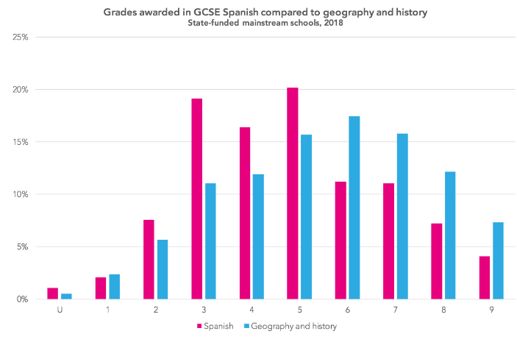

What are the key issues
- This is NOT to do with standards, pedagogy, time allocation or any other factors. It is a historical anomaly dating back to O-level which has been “baked-in” by the remit to QCA and then Ofqual to maintain comparable grading over time, formalised over the last 10 years by “comparable outcomes” whereby the grade distribution is kept similar from one year to the next, varied only for changes in the prior ability profile of those taking a particular subject.
- Not only is this unfair, it can often to lead to false conclusions being drawn:
  - Pupils think that they are not as good at ML, and parents could take a similar view, especially as the issue would have been there when they took their own GCSEs or O-levels
  - ML teachers may be unfairly thought to be under-performing - in particular any comparison using Progress 8 EBacc buckets will be comparing ML against Hi/Ge and Sciences - definitely NOT a level playing field!

What needs to happen?
It is important that the issue be widely known and understood to avoid incorrect conclusions being drawn, and pupils and parents need to know that a lower grade in ML does not mean that they are not doing as well in that subject.

Standards and grading for the new GCSEs in French, German and Spanish, first being examined in June 2026, need to be set by Ofqual in a way that brings GCSE ML into line with the other EBacc subjects.

Full details are available at https://all-london.org.uk/severe-grading/ including a recent overview for ALL’s Languages Today: https://all-london.org.uk/languages-today-article-on-severe-grading-winter-2023/

